Dr.SNS RAJALAKSHIMI COLLEGE OF ARTS AND SCIENCE

VIRTUALIZATION TECHNOLOGY FUNDAMENTALS
UNIT-I

UNIT-1

Understanding Virtualization

In recent years the term virtualization has become the industry’s newest buzzword. This raises the question … just what is virtualization? The first concept that comes to the mind of the average industry professional is running one or more guest operating systems on a host. However, digging a little deeper reveals this definition is too narrow. There are a large number of services, hardware, and software that can be “virtualized”. This article will take a look at these different types of virtualization along with the pros and cons of each.

1.1 Introduction of Virtualization:

Virtualization is the ability to run multiple virtual machines on a single piece of hardware. The hardware runs software which enables you to install multiple operating systems which are able to run simultaneously and independently, in their own secure environment, with minimal reduction in performance.
“In computing, virtualization is a broad term that refers to the abstraction of computer resources. Virtualization hides the physical characteristics of computing resources from their users, be they applications, or end users. This includes making a single physical resource (such as a server, an operating system, an application, or storage device) appear to function as multiple virtual resources; it can also include making multiple physical resources (such as storage devices or servers) appear as a single virtual resource...
In layman’s terms virtualization is often:
- The creation of many virtual resources from one physical resource.
- The creation of one virtual resource from one or more physical resource.
The term is frequently used to convey one of these concepts in a variety of areas such as networking, storage, and hardware.

1.2. History

Virtualization is not a new concept. One of the early works in the field was a paper by Christopher Strachey entitled "Time Sharing in Large Fast Computers". IBM began exploring virtualization with its CP-40 and M44/44X research systems. These in turn lead to the commercial CP-67/CMS. The virtual machine concept kept users separated while simulating a full stand-alone computer for each.
In the 80’s and early 90’s the industry moved from leveraging singular mainframes to running collections of smaller and cheaper x86 servers. As a result the concept of virtualization becomes less prominent. That changed in 1999 with VMware’s introduction of VMware workstation. This was followed by VMware’s ESX Server, which runs on bare metal and does not require a host operating system.

1.3. Understanding Virtualization

The process of virtualization is a way to create multiple virtually simulated instances over the computer hardware to utilize your system's underlying resources fully. This increases the productivity and efficiency of our professional and personal requirements.
The software hypervisor allows the elements of the system, such as storage, memory, processor, etc, to be distributed among multiple separate and secure virtual computers, created using the hypervisor, which is termed as virtual machines(VMs), where every virtual machine has its dedicated operating system which uses a part of the system's hardware resources for operation.

1.3.1. Virtualization describes

Virtualization describes a technology in which an application, guest OS or data storage is abstracted away from the true underlying hardware or software. A key use of virtualization technology is server virtualization, which uses a software layer -- called a hypervisor</a -- to emulate the underlying hardware.
Virtualization uses different software-based solutions to create an abstract layer on our computer hardware. This allows us to divide the hardware elements of a single computer (processors, memory, storage, and so on) into virtual machines (VMs). Each VM runs its operating system, which runs only on some of the underlying computer hardware but behaves like a stand-alone computer.
Simulation of OS-level virtualization
Virtualization can be categorized into two categories:
Categorization of virtualization

Hardware-based
In this implementation, the hypervisors provide the virtual machine's implementation through firmware, allowing it to run on the core hardware (CPU). Its also known as a type-00 hypervisor.

OS based
In this implementation, the hypervisors provide for the virtual machine's on top of the existing operating system. The new virtual machine(VM) also runs the conventional operating system. Its also known as a type-11 hypervisor.
The practical use cases of virtualization are:
- Cloud virtualization
- Storage virtualization
- CPU virtualization
- Network virtualization
And many more!

Overheads
Virtualization is associated with some overhead:

Additional access time
After virtualization, the virtual machines require additional time to access the memory due to the layer on top of the OS or core hardware.

Require extra space
The hypervisor requires extra space to implement its data structure and code, excluding the memory allocated to the virtual machine (VM) separately.

CPU utilization
Some percentage of the CPU is unavailable to the virtual machine (after virtualization) because the CPU is consumed by other virtual machines, VMware itself, or other processes.

1.4. Importance of Virtualization

Virtualization can increase IT agility, flexibility and scalability while creating significant cost savings. Greater workload mobility, increased performance and availability of resources, automated operations – they're all benefits of virtualization that make IT simpler to manage and less costly to own and operate.
Benefits of Virtualization
- Reduced upfront hardware and continuing operating costs.
- Minimized or eliminated downtime.
- Increased IT productivity and responsiveness.
- Greater business continuity and disaster recovery response.
- Simplified data center management.
- Faster provisioning of applications and resources.
Virtualized software is an application that will be "installed" into its own self-contained unit. Example of software virtualization is VMware software, virtual box etc. In the next pages, we are going to see how to install linux OS and windows OS on VMware application.

1.5. Understanding Virtualization Software operations:

1.5.1. What is Software Virtualization?
Software Visualization in Cloud Computing allows the single computer server to run one or more virtual environments. It is quite similar to virtualizations but here it abstracts the software installation procedure and creates a virtual software out of it.
In software virtualizations, an application will be installed which will perform the further task. One software is physical while others are virtual as it allows 2 or more operating system using only one computer.

1.5.2. Benefits of Software Virtualization
Here, is the list of Software Virtualization Advantages in Cloud Computing :

- Testing
It is easier to test the new operating system and software on VMs as it does not require any additional hardware and the testing can do within the same software. After the testing, the VM can move or delete for the further testing.
- Utilization
In software virtualization, there is higher efficiency in resource utilization if it tunes correctly. The VM can modify as per the requirement such as the user can modify ram, drive space, etc. It requires very less amount of hardware as compared to the equivalent number of physical machines.
- Efficient
It is efficient in a way such that it can run 12 virtual machines and eliminates the use of 12 physical boxes. This is the power cost as well as the cost of maintaining the server.
- Less Downtime
The software is upgrading and the upgrade in the VMs can do when the VM is working. VM can modify when it is working or it is not working which means that the downtime of it is very less.
- Flexible
It provides flexibility to the user so that the user can modify the software as per their demand. The modification can do within minutes and can adjust easily when the workload changes.
- Secure
It can protect with many hantaviruses. Moreover, there are several firewalls which prevent hacking and virus. The data in the software virtualization is safe as it stores in several different places so if the disaster takes place the data can retrieve easily.

1.5.3. Virtualization Software operations:
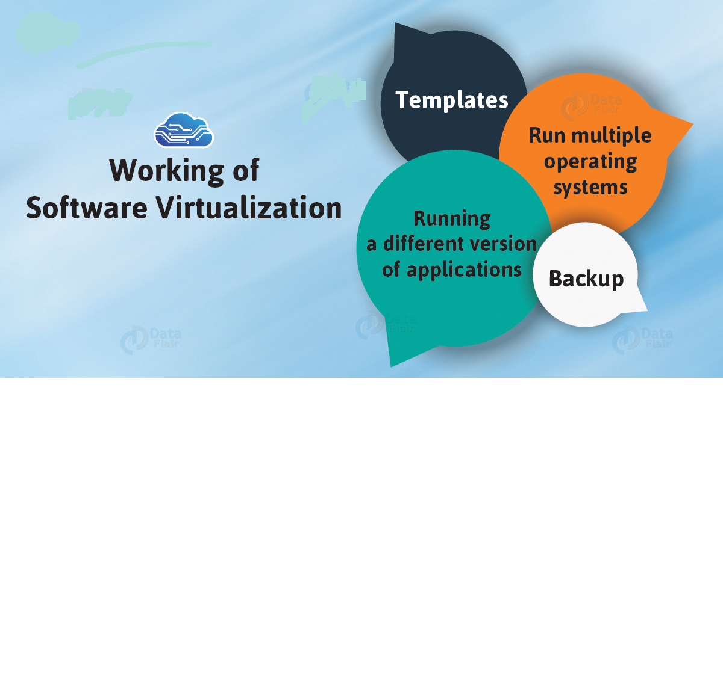
Figure-1.1

i.Backup
With the help of software virtualization, the entire operating system or server installation can be backed up. This also benefits in a way that if the new server hack just restoring the previous version will allow running the server.

ii. Run multiple operating systems
The different operating system can use in a single computer with the partition in the hard drive. The only thing to keep in mind is to keep a snapshot of everything. If the data drowns, it can retrieve from some other place.

iii. Running a different version of applications
With the help of software virtualization new as well as the old operating system can use. So a program, if it is not working on a particular operating system, we can check it on another one.

iv. Templates
After the configuration of VM as per the demand, it can convert into a template and this template can use to make multiple copies of the original one.

1.6. Hypervisor:

A hypervisor, also known as a virtual machine monitor or VMM, is software that creates and runs virtual machines (VMs). A hypervisor allows one host computer to support multiple guest VMs by virtually sharing its resources, such as memory and processing.
Understanding the concept of hypervisor:
A hypervisor is a process or a function to help admins isolate operating system and applications from the underlying hardware. Cloud computing uses it the most as it allows multiple guest operating systems (also known as virtual machines or VMs) to run simultaneously on a single host system. Administrators can use the resources efficiently by dividing computing resources (RAM, CPU, etc.) between multiple VMs.
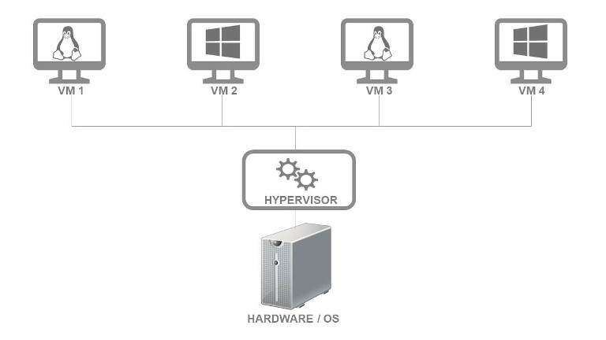
Figure-1.2
A hypervisor is a key element in virtualization, which has helped organizations achieve higher cost savings, improve their provisioning and deployment speeds, and ensure higher resilience with reduced downtimes.

1.6.1. The Evolution of Hypervisors
The use of hypervisors dates to the 1960s when IBM deployed them on time-sharing systems and leveraged them for testing new operating systems and hardware. During the 1960s, virtualization techniques were extensively used by developers wanting to test their programs without affecting the main production system. The mid-2000s witnessed another significant leap as Unix, Linux, and others experimented with virtualization. With advancements in processing power, companies built powerful machines capable of handling multiple workloads. In 2005, CPU vendors started offering hardware virtualization to their x86-based products, making hypervisors mainstream.

1.6.2. Why use a hypervisor?
Now that we’ve answered “what is a hypervisor,” it’ll be useful to explore some of their important applications to better understand the role hypervisors play in virtualized environments. Hypervisors simplify server management as VMs are independent of the host environment. In other words, the operation of one VM doesn’t affect other VMs or the underlying hardware. Therefore, even when one VM crashes, others can continue working without affecting performance. It allows administrators to move VMs between servers, a useful capability for workload balancing. As teams migrate VMs from one machine to another without stopping them, they can use this feature for fail-over. Moreover, a hypervisor is useful for running and testing programs across different operating systems.
However, the most important use case for hypervisors is to consolidate servers on the cloud. Data centers require server consolidation to minimize server sprawl. In fact, virtualization practices and hypervisors have become popular because they’re highly effective in solving the problem of underutilized servers. Instead of running different workloads on separate physical servers, virtualization enables administrators to easily leverage the unused hardware capacity to run multiple workloads simultaneously. They can match their workloads with proper physical resources, meeting their time, cost, and service level requirements.

1.6.3. What are the different types of hypervisors?
- Type 1 Hypervisors (Bare Metal or Native Hypervisors): Type 1 hypervisors are deployed directly over the host hardware. Direct access to the hardware without any underlying OS or device drivers makes such hypervisors highly efficient for enterprise computing. The implementation is also inherently secure against OS-level vulnerabilities. VMware ESXi, Microsoft Hyper-V, Oracle VM, and Xen are examples of type 1 hypervisors.
- Type 2 Hypervisors (Hosted Hypervisor): Type 2 hypervisors run as an application over a traditional OS. Developers, security professionals, or users who need to access applications only available on select OS versions often rely on type 2 hypervisors for their operations. KVM, VMware Server and Workstation, Microsoft Virtual PC, Oracle VM VirtualBox, and QEMU are some popular type 2 hypervisors.

1.7. Understanding the Role of a Hypervisor

The explanation of a hypervisor up to this point has been fairly simple: it is a layer of software that sits between the hardware and the one or more virtual machines that it supports. Its job is also fairly simple. The three characteristics defined by Popek and Goldberg illustrate these tasks:
- Provide an environment identical to the physical environment
- Provide that environment with minimal performance cost
- Retain complete control of the system resources
- Role of Hypervisor in Virtualization:
- Resource Allocation: One of the primary functions of the hypervisor is to allocate and manage resources on the host machine. This includes CPU, memory, and storage resources. The hypervisor ensures that each VM has access to the resources it needs to run, and it also monitors resource usage to prevent any one VM from consuming too much of the available resources
- Isolation: Another critical function of the hypervisor is to provide isolation between the virtual machines. Each VM runs in its own isolated environment, which means that any changes made to one VM do not affect the other VMs running on the same host. This ensures that the VMs are protected from each other, and it also improves security by preventing any unauthorized access between the VMs.
- Emulation of Hardware: The hypervisor emulates hardware for each virtual machine, which means that each VM has access to its own set of virtual hardware components. This includes virtual CPUs, memory, storage, network interfaces, and other devices. The hypervisor is responsible for translating requests from the VMs into instructions that the physical hardware can understand. This allows VMs to run different operating systems and applications without requiring any changes to the underlying hardware.
- Live Migration: The hypervisor also supports live migration, which allows VMs to be moved between physical hosts without any disruption to the running applications. This is particularly useful in environments where high availability and load balancing are critical, as it allows VMs to be moved to a different host in the event of hardware failure or maintenance.
- Backup and Recovery: The hypervisor also provides backup and recovery capabilities for virtual machines. This includes features such as snapshotting, which allows administrators to take a snapshot of a VM’s state at a specific point in time. This snapshot can be used to restore the VM to its previous state in the event of a failure or data loss.
In accordance with different IT workspace, you have multiple forms for virtualization:

1. Desktop Virtualization

In this type of virtualization, you can run multiple operating systems, each in its own virtual machine on the same system.
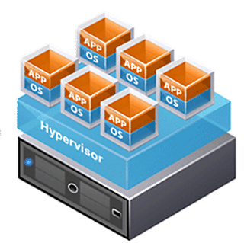
Figure-1.2
Types of desktop virtualization:
- Virtual desktop infrastructure runs numerous virtual machines on a central server and then hosts it to the host system according to the user's requirements. In this way, you can access any operating system from any device without installing the actual operating system in their local machine.
- Local desktop virtualization is the type that runs the hypervisor on the local system, which allows the user to install multiple operating systems simultaneously without affecting the host's operating system.
2. Network Virtualization
In this, the software creates a virtual instance of the network that can be used to manage from a single console. It forms the abstraction of the hardware components and functions (e.g., switches, routers, etc.), simplifying network management.
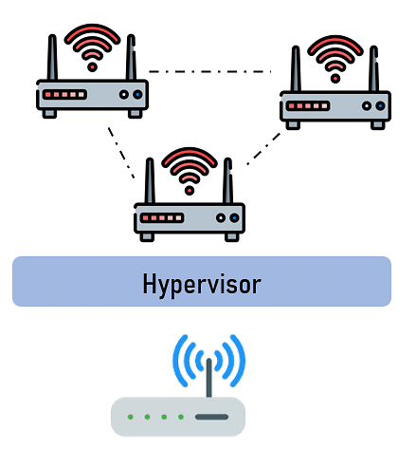
Figure-1.3
Types of network virtualization:
- Software-defined networking (SDN) virtualizes hardware that controls network traffic routing.
- Network function virtualization (NFV) virtualizes hardware appliances that provide network-specific functions easier to configure and manage, e.g., firewall, etc.

3. Storage Virtualization
This virtualization enables all the storage devices on the system to be accessed and be managed as a single storage unit pool for better maintenance.

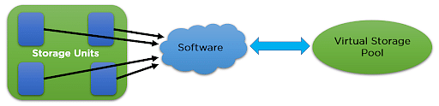
Figure-1.4
The storage virtualization collects all the storage into a single pool from which they can allocate to any of the VM on the network as required.
This step makes it easier for the hypervisor to assign storage for VMs with max efficiency and without wasting any hardware resources from our system.

4. Application Virtualization
In this virtualization process, the application runs without the need of installing it into the system, as they run on a virtual environment.
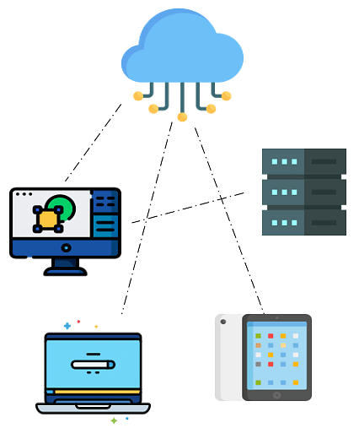
Figure-1.5
Types of Application virtualization:
- Local application virtualization runs on the host device but runs in a virtual environment, not in the hardware.
- Application virtualization, the application is on the server-side, and it sends some components to the host device according to the requirement.
- Server-based application virtualization runs only on the server-side and sends the only interface to the client system.

5. GPU Virtualization

This particular virtualization type increases computing efficiency by assisting with heavy graphic processing or related matters.
This virtualization integrates multiple VMs or uses a single VM for performing such tasks of graphics-related work, heavy video editing, and some parts of Artificial Intelligence (AI) working.

6. Cloud Virtualization

This type of virtualization is dependent on the process of virtualization to a large extent, as it virtualizes the cloud server, data, storage, and other parts of the hardware resources.
Services offered by the cloud virtualization:
- Infrastructure as a service (IaaS): This service provides help by virtualizing storage, server, and network-related work, where you can design them according to your requirements.
- Platform as service (PaaS): Virtualizing databases, programming, and development tools require this service.
- Software as a service (SaaS): As the name suggests, this service provides virtualization for software-based applications to be hosted on the cloud.

1.8. Types of Virtualization
Today the term virtualization is widely applied to a number of concepts including:
- Server Virtualization
- Client / Desktop / Application Virtualization
- Network Virtualization
- Storage Virtualization
- Service / Application Infrastructure Virtualization
In most of these cases, either virtualizing one physical resource into many virtual resources or turning many physical resources into one virtual resource is occurring.

1.8.1. Server Virtualization

Server virtualization is the most active segment of the virtualization industry featuring established companies such as VMware, Microsoft, and Citrix. With server virtualization one physical machine is divided many virtual servers. At the core of such virtualization is the concept of a hypervisor (virtual machine monitor). A hypervisor is a thin software layer that intercepts operating system calls to hardware. Hypervisors typically provide a virtualized CPU and memory for the guests running on top of them. The term was first used in conjunction with the IBM CP-370.
Hypervisors are classified as one of two types:
- Type 1 – This type of hypervisor is also known as native or bare-metal. They run directly on the hardware with guest operating systems running on top of them. Examples include VMware ESX, CitrixXenServer,and Microsoft’sHyper-V.
Type 2 – This type of hypervisor runs on top of an existing operating system with guests running at a third level above hardware. Examples include VMware Workstation and SWSoft’s Parallels Desktop.
Related to type 1 hypervisors is the concept of paravirtualization. Paravirtualization is a technique in which a software interface that is similar but not identical to the underlying hardware is presented. Operating systems must be ported to run on top of a paravirtualized hypervisor. Modified operating systems use the "hypercalls" supported by the paravirtualized hypervisor to interface directly with the hardware. The popular Xen project makes use of this type of virtualization. Starting with version 3.0 however Xen is also able to make use of the hardware assisted virtualization technologies of Intel (VT-x) and AMD (AMD-V). These extensions allow Xen to run unmodified operating systems such as Microsoft Windows.
Server virtualization has a large number of benefits for the companies making use of the technology. Among those frequently listed:
- Increased Hardware Utilization – This results in hardware saving, reduced administration overhead, and energy savings.
- Security – Clean images can be used to restore compromised systems. Virtual machines can also provide sandboxing and isolation to limit attacks.
- Development – Debugging and performance monitoring scenarios can be easily setup in a repeatable fashion. Developers also have easy access to operating systems they might not otherwise be able to install on their desktops.
Correspondingly there are a number of potential downsides that must be considered:
- Security – There are now more entry points such as the hypervisor and virtual networking layer to monitor. A compromised image can also be propagated easily with virtualization technology.
- Administration – While there are less physical machines to maintain there may be more machines in aggregate. Such maintenance may require new skills and familiarity with software that administrators otherwise would not need.
- Licensing/Cost Accounting – Many software-licensing schemes do not take virtualization into account. For example running 4 copies of Windows on one box may require 4 separate licenses.
- Performance – Virtualization effectively partitions resources such as RAM and CPU on a physical machine. This combined with hypervisor overhead does not result in an environment that focuses on maximizing performance.

1.8.2. Application/Desktop Virtualization
Virtualization is not only a server domain technology. It is being put to a number of uses on the client side at both the desktop and application level. Such virtualization can be broken out into four categories:
- Local Application Virtualization/Streaming
- Hosted Application Virtualization
- Hosted Desktop Virtualization
- Local Desktop Virtualization

Application virtualization as follows:

Application virtualization is an umbrella term that describes software technologies that improve manageability and compatibility of legacy applications by encapsulating applications from the underlying operating system on which they are executed. A fully virtualized application is not installed in the traditional sense, although it is still executed as if it is. Application virtualization differs from operating system virtualization in that in the latter case, the whole operating system is virtualized rather than only specific applications.
With streamed and local application virtualization an application can be installed on demand as needed. If streaming is enabled then the portions of the application needed for startup are sent first optimizing startup time. Locally virtualized applications also frequently make use of virtual registries and file systems to maintain separation and cleanness from the user’s physical machine. Examples of local application virtualization solutions include Citrix Presentation Server and Microsoft SoftGrid. One could also include virtual appliances into this category such as those frequently distributed via VMware’s VMware Player.
Hosted application virtualization allows the user to access applications from their local computer that are physically running on a server somewhere else on the network. Technologies such as Microsoft’s RemoteApp allow for the user experience to be relatively seamless include the ability for the remote application to be a file handler for local file types.
Benefits of application virtualization include:
- Security – Virtual applications often run in user mode isolating them from OS level functions.
- Management – Virtual applications can be managed and patched from a central location.
- Legacy Support – Through virtualization technologies legacy applications can be run on modern operating systems they were not originally designed for.
- Access – Virtual applications can be installed on demand from central locations that provide failover and replication.
Disadvantages include:
- Packaging – Applications must first be packaged before they can be used.
- Resources – Virtual applications may require more resources in terms of storage and CPU.
- Compatibility – Not all applications can be virtualized easily.

Desktop virtualization as:

Desktop virtualization (or Virtual Desktop Infrastructure) is a server-centric computing model that borrows from the traditional thin-client model but is designed to give administrators and end users the best of both worlds: the ability to host and centrally manage desktop virtual machines in the data center while giving end users a full PC desktop experience.
Hosted desktop virtualization is similar to hosted application virtualization, expanding the user experience to be the entire desktop. Commercial products include Microsoft’s Terminal Services, Citrix’s XenDesktop, and VMware’s VDI.
Benefits of desktop virtualization include most of those with application virtualization as well as:
- High Availability – Downtime can be minimized with replication and fault tolerant hosted configurations.
- Extended Refresh Cycles – Larger capacity servers as well as limited demands on the client PCs can extend their lifespan.
- Multiple Desktops – Users can access multiple desktops suited for various tasks from the same client PC.
Disadvantages of desktop virtualization are similar to server virtualization. There is also the added disadvantage that clients must have network connectivity to access their virtual desktops. This is problematic for offline work and also increases network demands at the office.
The final segment of client virtualization is local desktop virtualization. It could be said that this is where the recent resurgence of virtualization began with VMware’s introduction of VMware Workstation in the late 90’s. Today the market includes competitors such as Microsoft Virtual PC and Parallels Desktop. Local desktop virtualization has also played a key part in the increasing success of Apple’s move to Intel processors since products like VMware Fusion and Parallels allow easy access to Windows applications. Some the benefits of local desktop virtualization include:
- Security – With local virtualization organizations can lock down and encrypt just the valuable contents of the virtual machine/disk. This can be more performant than encrypting a user’s entire disk or operating system.
- Isolation – Related to security is isolation. Virtual machines allow corporations to isolate corporate assets from third party machines they do not control. This allows employees to use personal computers for corporate use in some instances.
- Development/Legacy Support – Local virtualization allows a user’s computer to support many configurations and environments it would otherwise not be able to support without different hardware or host operating system. Examples of this include running Windows in a virtualized environment on OS X and legacy testing Windows 98 support on a machine that’s primary OS is Vista.

1.8.3. Network Virtualization
Up to this point the types of virtualization covered have centered on applications or entire machines. These are not the only granularity levels that can be virtualized however. Other computing concepts also lend themselves to being software virtualized as well. Network virtualization is one such concept.

In computing, network virtualization is the process of combining hardware and software network resources and network functionality into a single, software-based administrative entity, a virtual network. Network virtualization involves platform virtualization, often combined with resource virtualization. Network virtualization is categorized as either external, combining many networks, or parts of networks, into a virtual unit, or internal, providing network-like functionality to the software containers on a single system…
Using the internal definition of the term, desktop and server virtualization solutions provide networking access between both the host and guest as well as between many guests. On the server side virtual switches are gaining acceptance as a part of the virtualization stack. The external definition of network virtualization is probably the more used version of the term however. Virtual Private Networks (VPNs) have been a common component of the network administrators’ toolbox for years with most companies allowing VPN use. Virtual LANs (VLANs) are another commonly used network virtualization concept. With network advances such as 10 gigabit Ethernet, networks no long need to be structured purely along geographical lines. Companies with products in the space include Cisco and 3Leaf.
In general benefits of network virtualization include:
- Customization of Access – Administrators can quickly customize access and network options such as bandwidth throttling and quality of service.
- Consolidation – Physical networks can be combined into one virtual network for overall simplification of management.
Similar to server virtualization, network virtualization can bring increased complexity, some performance overhead, and the need for administrators to have a larger skill set.

1.8.4. Storage Virtualization
Another computing concept that is frequently virtualized is storage. Unlike the definitions we have seen up to this point that have been complex at times,
Storage virtualization simply as Storage virtualization refers to the process of abstracting logical storage from physical storage.
While RAID at the basic level provides this functionality, the term storage virtualization typically includes additional concepts such as data migration and caching. Storage virtualization is hard to define in a fixed manner due to the variety of ways that the functionality can be provided. Typically, it is provided as a feature of:
- Host Based with Special Device Drivers
- Array Controllers
- Network Switches
- Stand Alone Network Appliances
Each vendor has a different approach in this regard. Another primary way that storage virtualization is classified is whether it is in-band or out-of-band. In-band (often called symmetric) virtualization sits between the host and the storage device allowing caching. Out-of-band (often called asymmetric) virtualization makes use of special host based device drivers that first lookup the meta data (indicating where a file resides) and then allows the host to directly retrieve the file from the storage location. Caching at the virtualization level is not possible with this approach.
General benefits of storage virtualization include:
- Migration – Data can be easily migrated between storage locations without interrupting live access to the virtual partition with most technologies.
- Utilization – Similar to server virtualization, utilization of storage devices can be balanced to address over and under utilization.
- Management – Many hosts can leverage storage on one physical device that can be centrally managed.
- Some of the disadvantages include:
- Lack of Standards and Interoperability – Storage virtualization is a concept and not a standard. As a result vendors frequently do not easily interoperate.
- Metadata – Since there is a mapping between logical and physical location, the storage metadata and its management becomes key to a working reliable system.
- Backout – The mapping between local and physical locations also makes the backout of virtualization technology from a system a less than trivial process.

1.8.5. Service / Application Infrastructure Virtualization
Enterprise application providers have also taken note of the benefits of virtualization an begun offering solutions that allow the virtualization of commonly used applications such as Apache as well as application fabric platforms that allow software to easily be developed with virtualization capabilities from the ground up.
Application infrastructure virtualization (sometimes referred to as application fabrics) unbundle an application from a physical OS and hardware. Application developers can then write to a virtualization layer. The fabric can then handle features such as deployment and scaling. In essence this process is the evolution of grid computing into a fabric form that provides virtualization level features. Companies such as Appistry and DataSynapse provides features including:
- Virtualized Distribution
- Virtualized Processing
- Dynamic Resource Discovery

IBM has also embraced the virtualization concept at the application infrastructure level with the rebranding and continued of enhancement of Websphere XD as Websphere Virtual Enterprise. The product provides features such as service level management, performance monitoring, and fault tolerance. The software runs on a variety of Windows, Unix, and Linux based operating systems and works with popular application servers such as WebSphere, Apache, BEA, JBoss, and PHP application servers. This lets administrators deploy and move application servers at a virtualization layer level instead of at the physical machine level.

Final Thoughts
In summary it should now be apparent that virtualization is not just a server-based concept. The technique can be applied across a broad range of computing including the virtualization of:
- Entire Machines on Both the Server and Desktop
- Applications/Desktops
- Storage
- Networking
- Application Infrastructure
The technology is evolving in a number of different ways but the central themes revolve around increased stability in existing areas and accelerating adoption by segments of the industry that have yet to embrace virtualization. The recent entry of Microsoft into the bare-metal hypervisor space with Hyper-V is a sign of the technology’s maturity in the industry.
Beyond these core elements the future of virtualization is still being written. A central dividing line is feature or product. For some companies such as RedHat and many of the storage vendors, virtualization is being pushed as a feature to complement their existing offerings. Other companies such as VMware have built entire businesses with virtualization as product. InfoQ will continue to cover the technology and companies involved as the space evolves.

